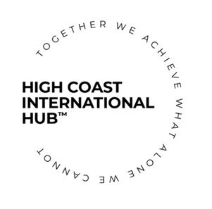

The High Coast International Hub AGM 2023

Agenda

Date: 20230620
Time: 12.00-13.00
Location: Öviksindustrigrupp Board Room, Torggatan 10, 891 31 Örnsköldsvik

Opening of the Meeting
Meeting members invited: Board members, company members, annual members and ambassadors
Members attending: TBC

Elections for the Meeting
- Election for role as Chairperson for the meeting –
- Election for role as Secretary for the meeting –
- Election for role of vote counters for the meeting –

Announcements:
- Anna Edblad has relinquished her seat at the Board

Motions

Motion to change statutes point number 8 (Board), from a chairman, 3 members and 2 deputies to a chairman, an executive director, an executive manager, a treasurer and 7 board members.

Election of the Officers and members of the Board of the High Coast International Hub

The following names are nominated for the 2023-2024 Board:
- Rory Moore – Chairperson / President

- Jennie Saporito – Treasurer

- Sam Coleman – Executive Director

- Chiara Corbatto – Executive Manager

- Hanna Flemström-Coleman – Board Member

- Peter Gimbergsson – Board Member

- Neil Johnson – Board Member

- Caroline Lindberg – Board Member

- Gary Cass – Board Member

- Jonas Fahrni – Board Member

- Henrik Olsén – Board Member

Votes by proxy:
Claudia Quineche – proxy designated: Chiara Corbatto
Alexandre Salou – proxy designated: Chiara Corbatto

(Vote counters will confirmed the vote count)

Presentations
Review of 2022-2023 activities

Financial overview

Closing of the Meeting
The Chairperson will formally close the meeting.

