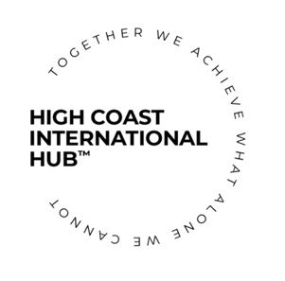

The High Coast International Hub AGM 2024

Agenda

Date: 20240614
Time: 15.00-16.00
Location: Kronan, Järnvägsgatan 6, 891 39 Örnsköldsvik

Meeting members invited: Board members, company members, annual members and ambassadors
Members attending: Rory Moore, Sam Coleman, Neil Johnson, Jennie Saporito, Oleg Girnyak, Gary Cass, Alexandre Salou

Opening of the Meeting
The chairperson opens the meeting.

Elections for the Meeting
- Election for role as Chairperson for the meeting – Rory Moore is nominated
- Election for role as Secretary for the meeting – Chiara Corbatto is nominated
- Election for role of vote counters for the meeting – Neil Johnson and Oleg Girnyak are nominated
Voted by acclamation

Announcements
- Gary Cass has relinquished his seat at the board
- Rory Moore has stepped down as chairperson and has relinquished his seat at the board

Election of the Officers and members of the Board of the High Coast International Hub

The following names are nominated for the 2024-2025 Board:

- Neil Johnson - Chairperson / President
Members voted by acclamation

- Jennie Saporito – Treasurer
Members voted by acclamation

- Sam Coleman – Secretary / Vice President
Members voted by acclamation

- Caroline Lindberg – Board member
Members voted by acclamation

- Henrik Olsén – Board member
Members voted by acclamation

- Peter Gimbergsson – Board member
Members voted by acclamation

- Oleg Girnyak – Board member
Members voted by acclamation

- Alexandre Salou – Board member
Members voted by acclamation

(Vote counters will confirmed the vote count)

Elections of the Signatories of the High Coast International Hub (for handwritten and digital signature):

- Neil Johnson is nominated
- Sam Coleman is nominated
- Jennie Saporito is nominated
Voted by acclamation

Presentations

- Chiara runs a presentation with a summary and review of 2023-2024 activities. Neil suggests and updates the members regarding a possible Club activity in August.

- Sam gives a financial overview and update on funding situation and Leader Höga Kusten application aimed at scaling up the High Coast International Hub to the whole High Coast region. There is a high chance that activities will stop after September 2024 and start again once the funds have been issued, in 2025, if the association’s application goes through.

Points of business:

- The members discuss about raising the membership fees for the corporate members in order to be able to support the Club activities and the International Day, and how to explain the decision to the companies.

Closing of the Meeting
The Chairperson formally closes the meeting.

